Fitness and Dance Studio
FITNESS SPECIAL
ALL CLASSES FREE!!!
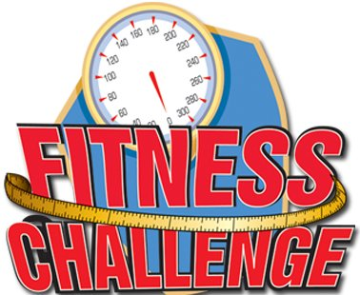
10:00AM – ZUMBA/TONING
12 NOON – BELLYDANCE FOR FITNESS
2:00PM – R. I. P. P. E. D.
4:00PM – STRETCH & STRUT

SWEAT, TONE AND BURN CALORIES
INSTEAD OF
SHOP AND SPEND MONEY
